Task 01:

class Animal {
void sound() {
sout(" sounds of different animals");
}
}
class Cat extends Animal{
@Override
void sound() {
sout(" Meow is the sound of cat");
}
}
class Main{
psvm(String[] args) {
Animal obj = new Cat();
obj.sound(); //Meow is the sound of cat
}
}
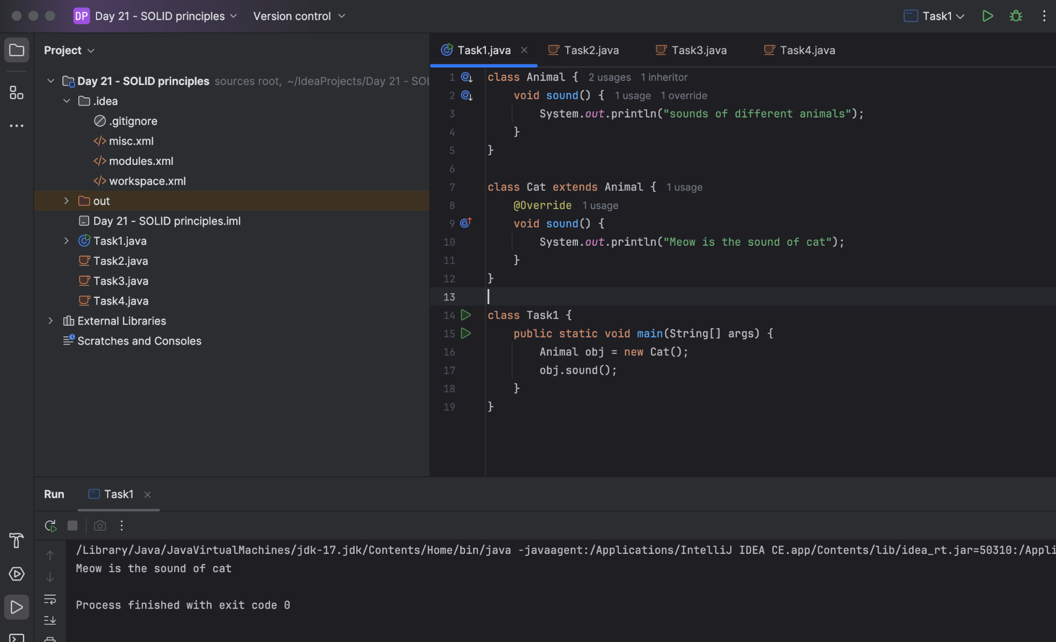

Task 02:

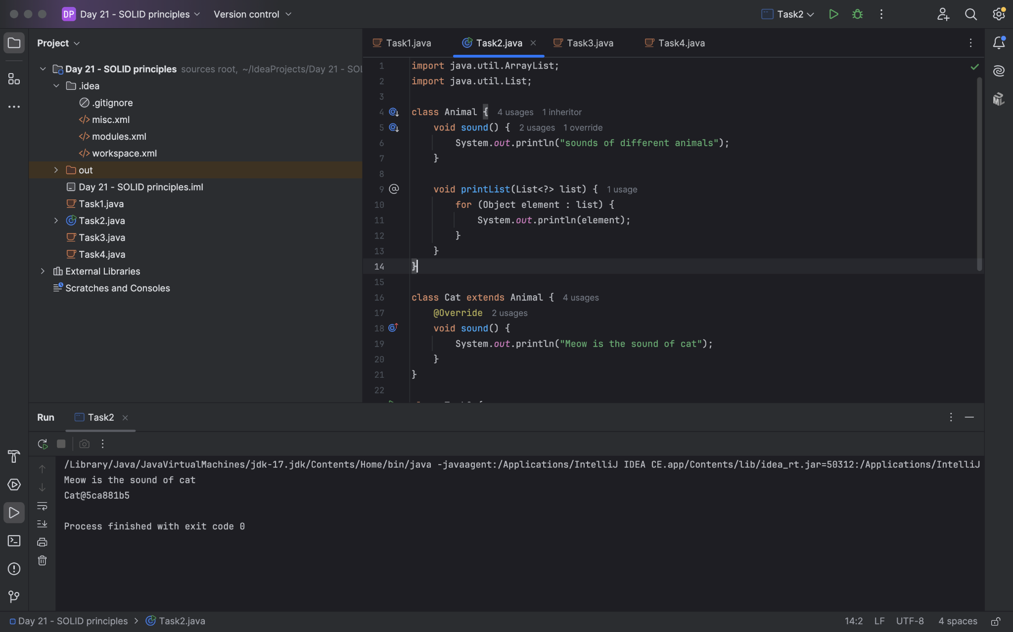

Task 03:

Upper Bounded Wildcards

void animalSound(List<? extends Animal> animalList) {
for(Animal elements : animalList
elements.sound();
}
}
List<Cat> cats = new ArrayList<>();
cats.add(new Cat());
animalSound(cats); //meow
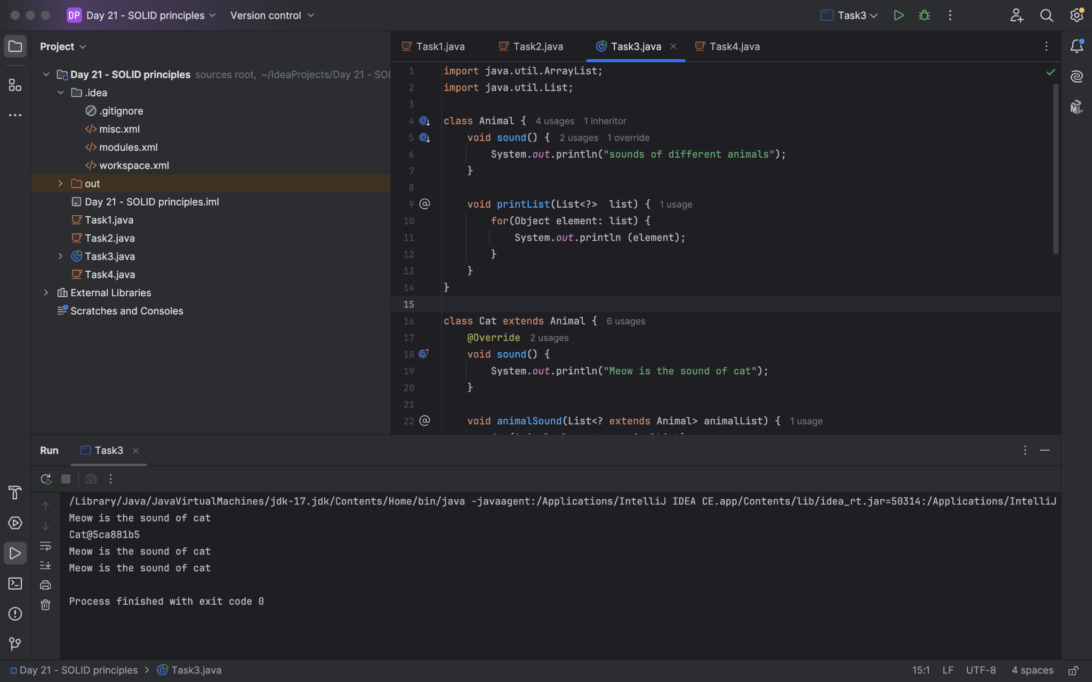
Task04:

lower Bounded Wildcards

void addAcat(List<? super Cat> cats) {
cats.add(new Cat());
}
List<Animal> animals = new ArrayList<>();
addAcat(animals); //

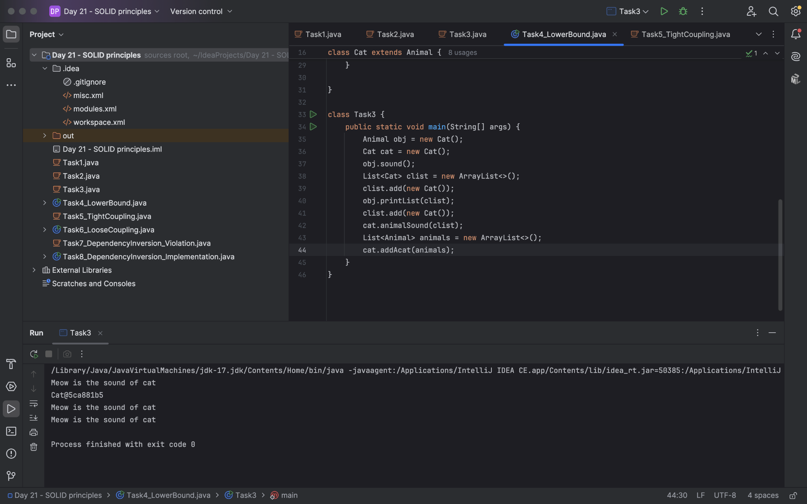

Task05:

// tight coupling

class Student {
public int roll_no = 10;
//private int roll_no = 10; // this code breaks...
public int getRoll() {
sout("getRoll method");
return roll_no;
}
public void setRoll(int roll) {
if(!(roll > 100)
roll_no = roll;
}
}
class Tight_coupling {
psvm(String....) {
Student sobj = new Student();
sobj.roll_no = 10; // we are not following the rule of Student class roll no > 100..
//sobj.roll_no = 110;
sout("the roll no of student is "+ sobj.roll_no); // 110 // private - error //10
}
}

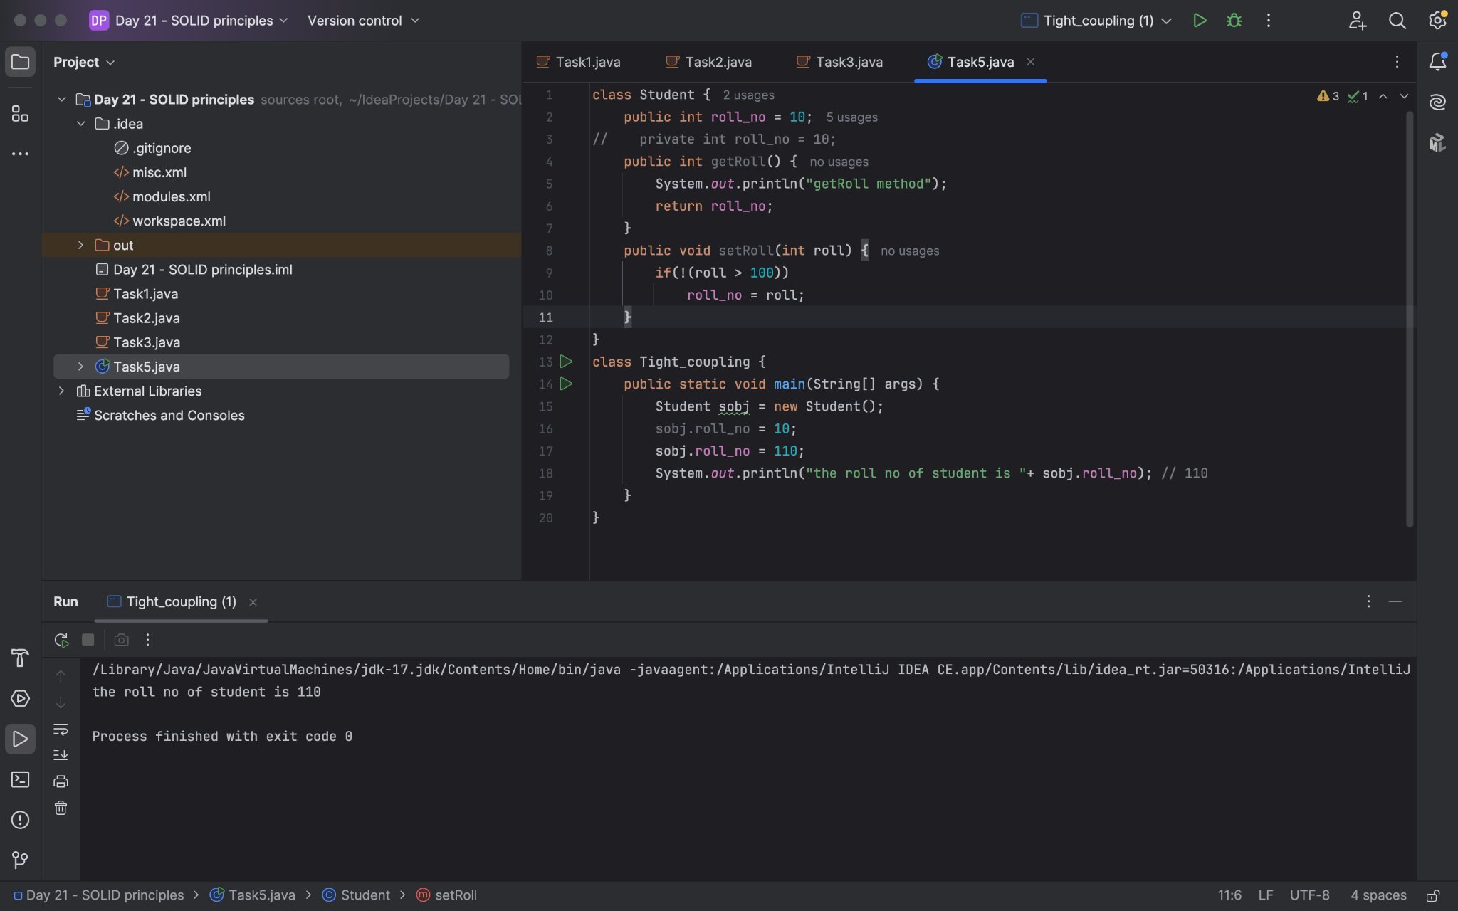

Task06:

// loose coupling

class Student {
private int roll_no = 0;
public int getRoll() {
sout("getRoll method");
return roll_no;
}
public void setRoll(int roll) {
if(!(roll > 100)
roll_no = roll;
}
}
class Loose_coupling {
psvm(String....) {
Student sobj = new Student();// Person pobj = new Student(); // person got a bonus
sobj.setRoll(10);
sout("the roll no of student is "+ sobj.getroll();
}
}

/*

Module 1 Module 2 Module 3
independent .. they do communicate

// we should do coupling -- importance

good maintainability
testability
Error propagation
high coupling - errors and it will propagate throught the project.. not at all recommandable..
reusability:

No coupling :

the modules wont interact with eachother.. -- completely independent..

*/

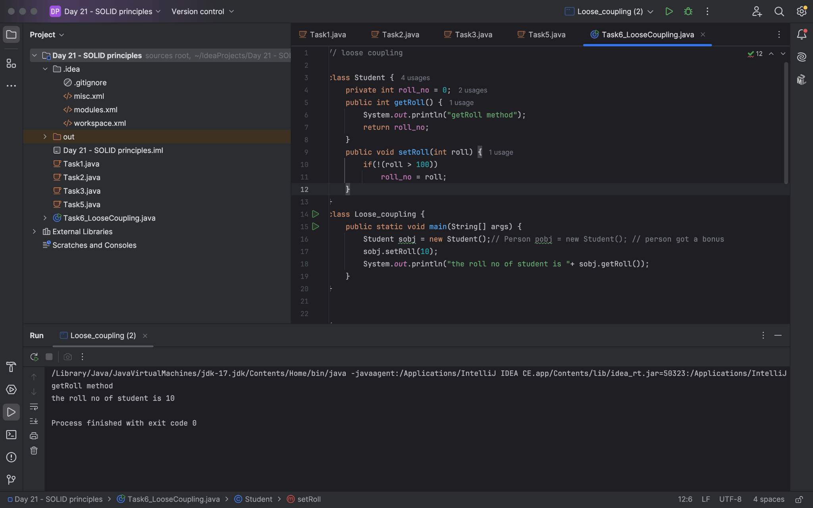

Task 07:

//DIP violating

class LightBulb {
void turnOn() {
sout("light turned on");
}
void turnOff() {
sout("light is off");
}
}
class Switch { // switch class directly depends on the lightbulb class ---- DIP violating
LightBulb lbulbobj;
Switch(LightBulb lbulbobj) {
this.lbulbobj = lbulbobj;
}
void operates(){
lbulbobj.turnOn();
}
psvm(....){
LightBulb lbulbobj = new lightBulb();
Switch Switchobj = new Switch(lbulbobj);
Switchobj.operate();
}
}

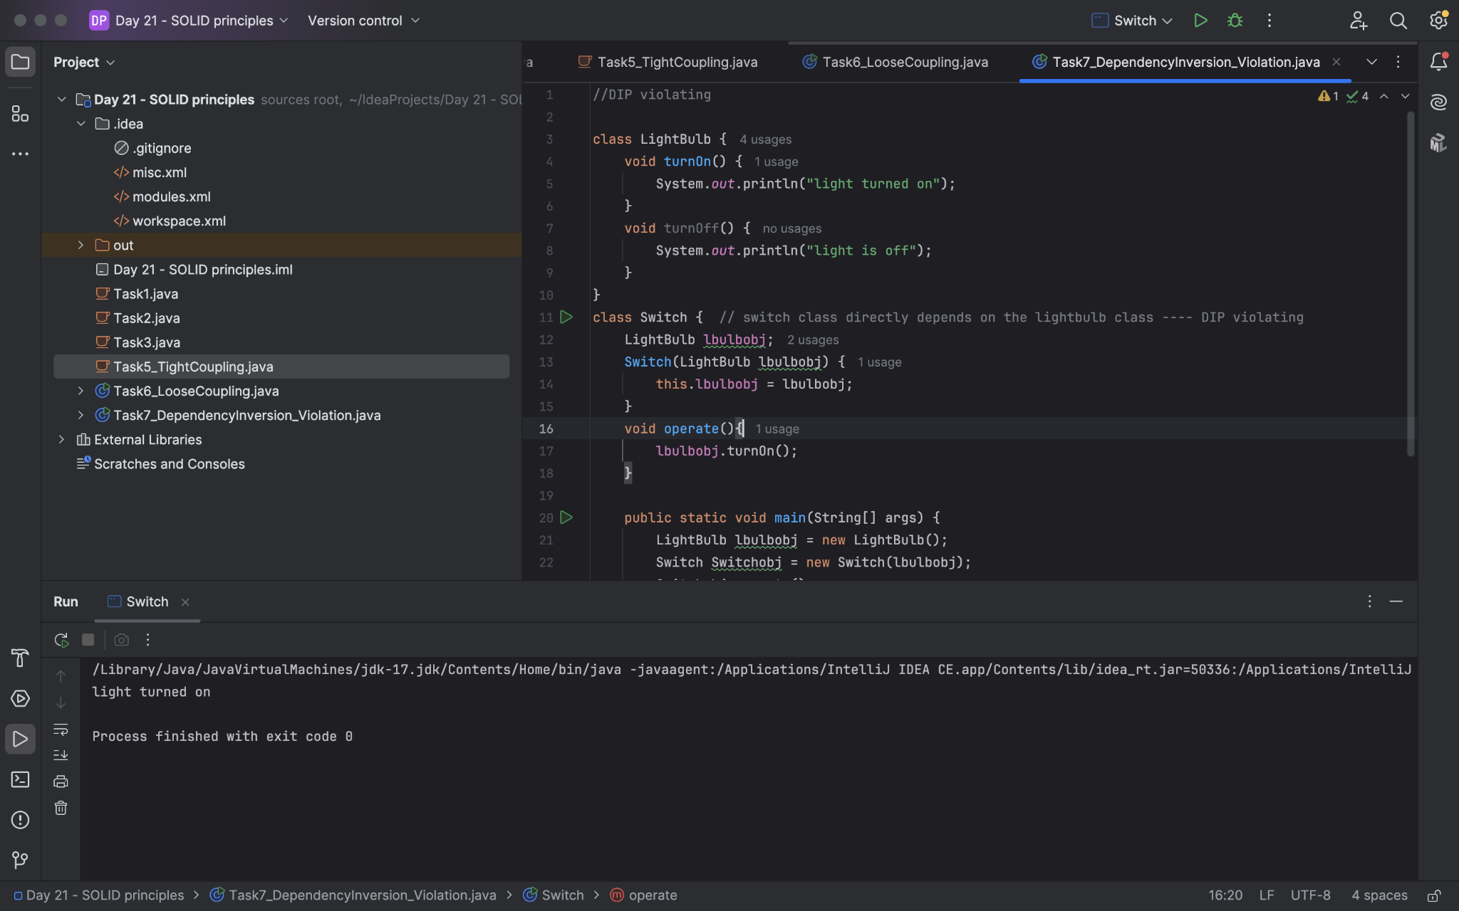

Task 08:

DIP implementation:
interface SwitchOnOff {
void turnOn();
void turnOff(); // void remoteControl();// void alexaVoiceControl();
}
class LightBulb {
void turnOn() {
sout("light turned on");
}
void turnOff() {
sout("light is off");
}
} // or class fan, class inverter, class washing machine...(in future remote for washing machine
// i can extend without modification..
class Switch { // switch is depending on switchonoff class not on light bulb..
SwitchOnOff device;
void Switch(SwitchOnOff device) {
this.device = device;
}
void operates() {
device.turnOn();
}
}
class DIP {
psvm(....){
SwitchOnOff lbulbobj = new LightBulb();
Switch lightswitch = new Switch(lbulbobj);
lightswitch.operate();
}
}

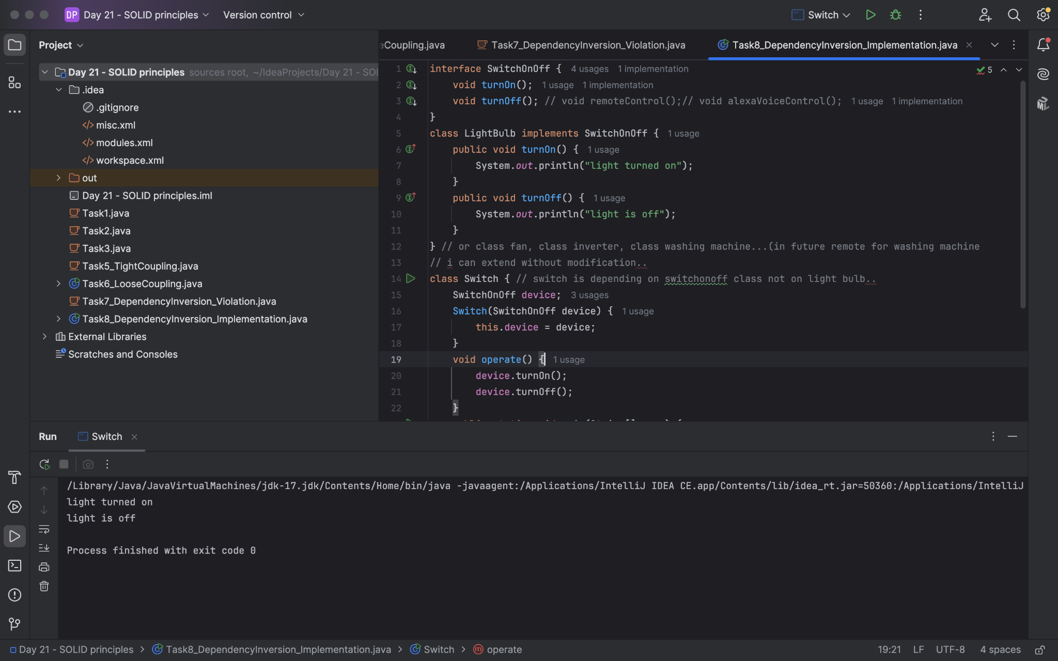

Task 09:

Why should we choose Composition over Inheritance?

Loose coupling

Flexibility

Better encapsulation

Home Tasks

Task 01:
Dependency:

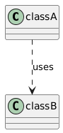

Definition: Class A uses class B, but neither class A nor class B strictly owns each other. The relationship exists temporarily.
Example:
class Engine {
func start() {
print("Engine starting")
}
}

class Car {
func drive() {
let engine = Engine() // Dependency
engine.start()
print("Car is driving")
}
}
// Usage
let myCar = Car()
myCar.drive()
In this example, Car depends on Engine to perform the drive function, but Car does not hold a reference to Engine beyond its use.
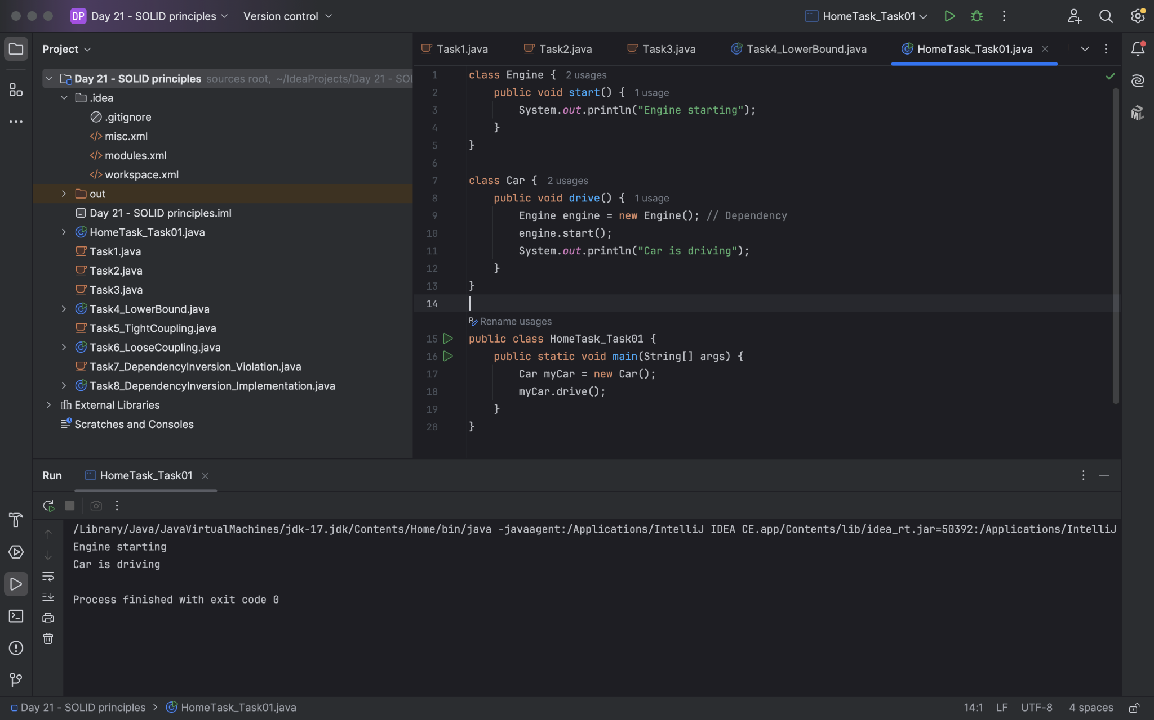
Task 02:

Aggregation

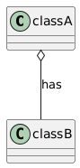

Definition: Class A contains a reference to class B, but class B can exist independently of class A. This relationship is often described as “has-a.”
Example:
class Driver {
var name: String

init(name: String) {
self.name = name
}
}

class Car {
var driver: Driver? // Aggregation

init(driver: Driver?) {
self.driver = driver
}
}

// Usage
let driver = Driver(name: "John")
let myCar = Car(driver: driver)
Here, Car has a Driver. If the Car is destroyed, the Driver can still exist independently.
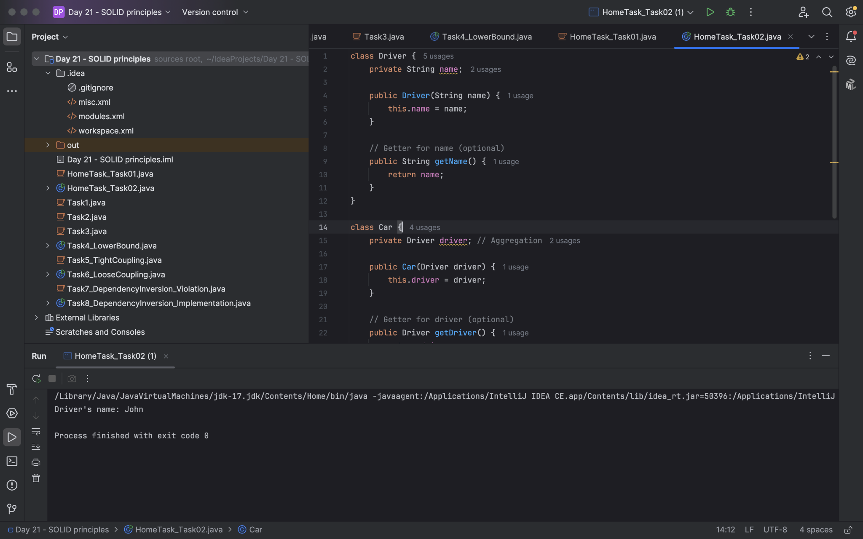

Task 03:

Composition

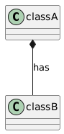

Definition: Class A owns class B, meaning if class A is destroyed, class B will be too. This is a strong ownership relationship.
Example:
class Wheel {
init() {
print("Wheel created")
}
}

class Car {
var wheels: [Wheel] // Composition

init() {
self.wheels = [Wheel(), Wheel(), Wheel(), Wheel()] // Wheels are created and owned by Car
}
}

// Usage
let myCar = Car() // All wheels created with the car
In this case, when Car is instantiated, its Wheels are created and completely owned by the Car.
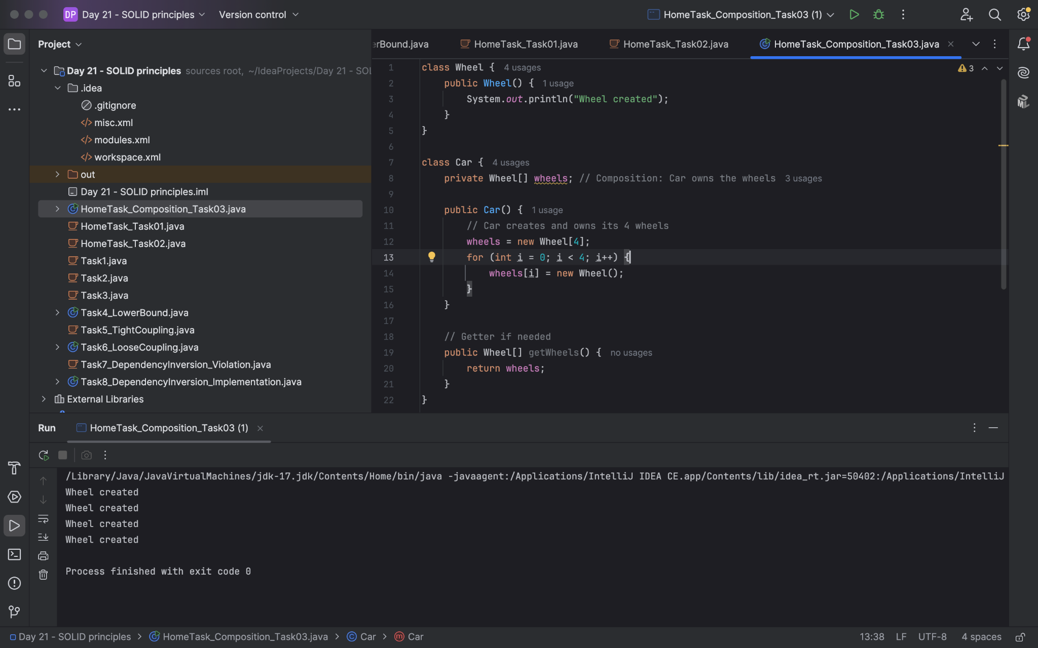
Task 04:

Based on the diagrammatic representation, can you write a program.

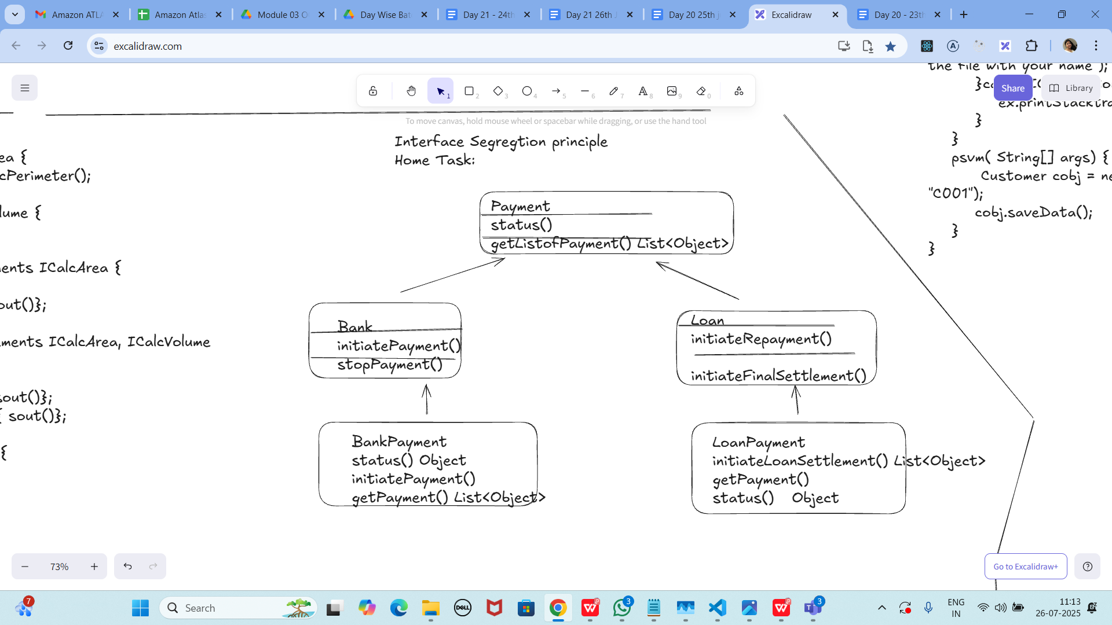

Program:

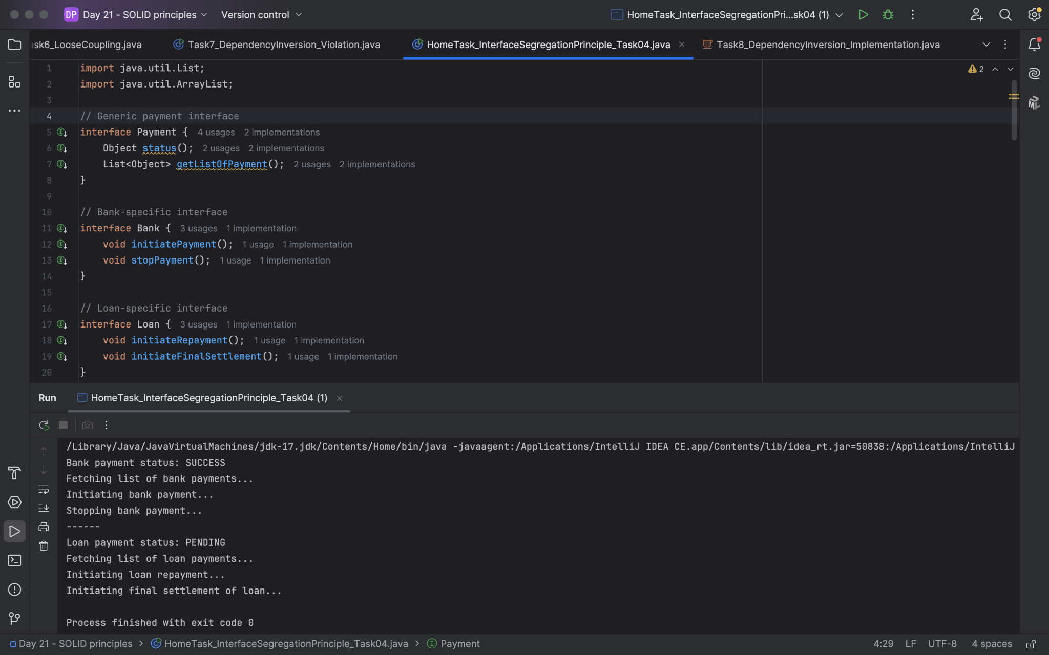

Task 05:

Violation of Liskov

abstract class Bird {
abstract void fly() ;
}
class Eagle extends Bird {
@Override
public void fly() {
sout(" Eagles fly");
}
}
class Ostrich extends Bird {
@Override
public void fly() { // dummy implentation
sout("cant fly high but It lays big egg");
}
}
class Driverclass{
psvm(String[] args){

}
}

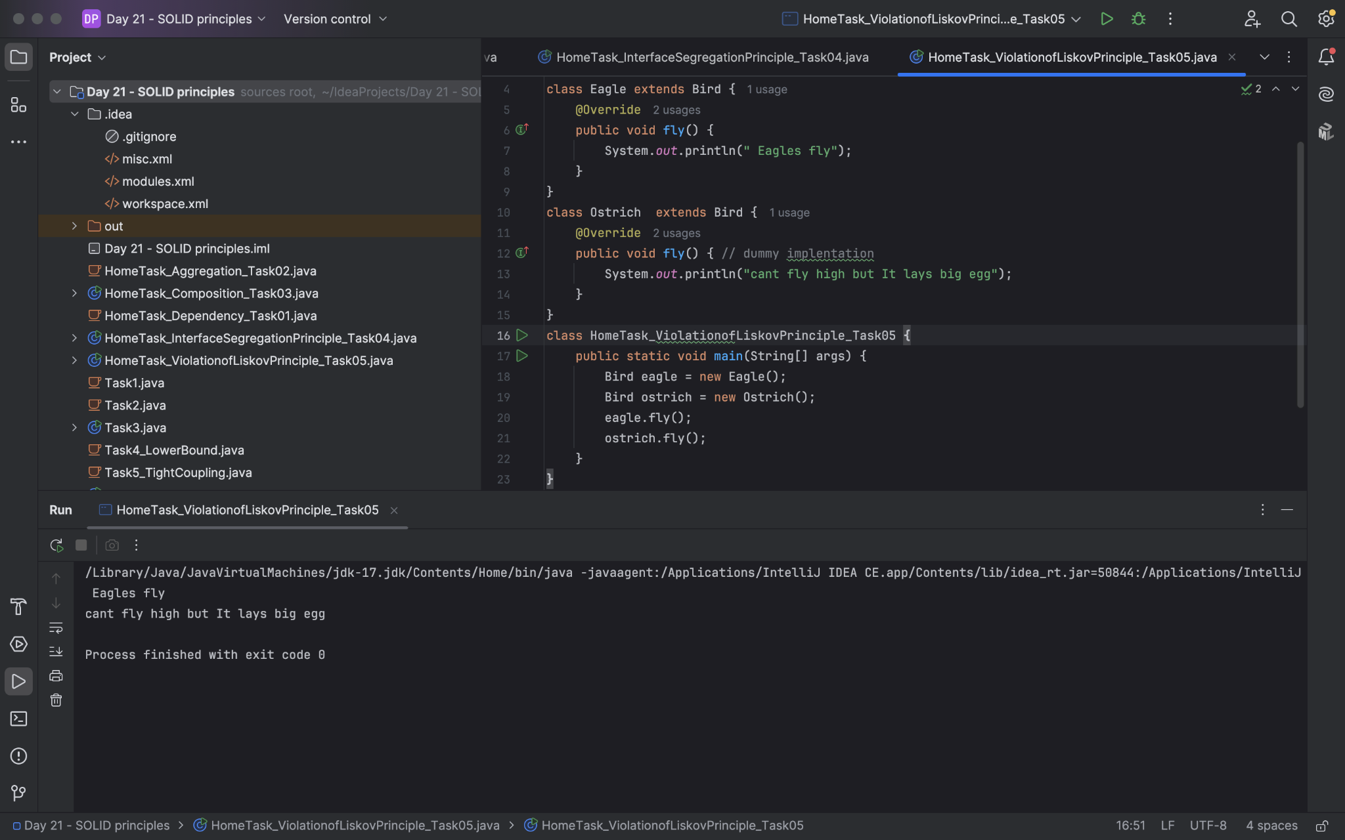
Task 06:

Implementation of Liskov

abstract class BirdsthatFly {
abstract void fly() ;
}
abstract class BirdsthatDontFly {
abstract void Speciality() ;
}
class Eagle extends BirdsthatFly {
@Override
public void fly() {
sout(" Eagles fly");
}
}
class Ostrich extends BirdsthatDontFly {
@Override
public void Speciality() {
sout("It lays big egg");
}
}
class Driverclass{
psvm(String[] args){

}
}

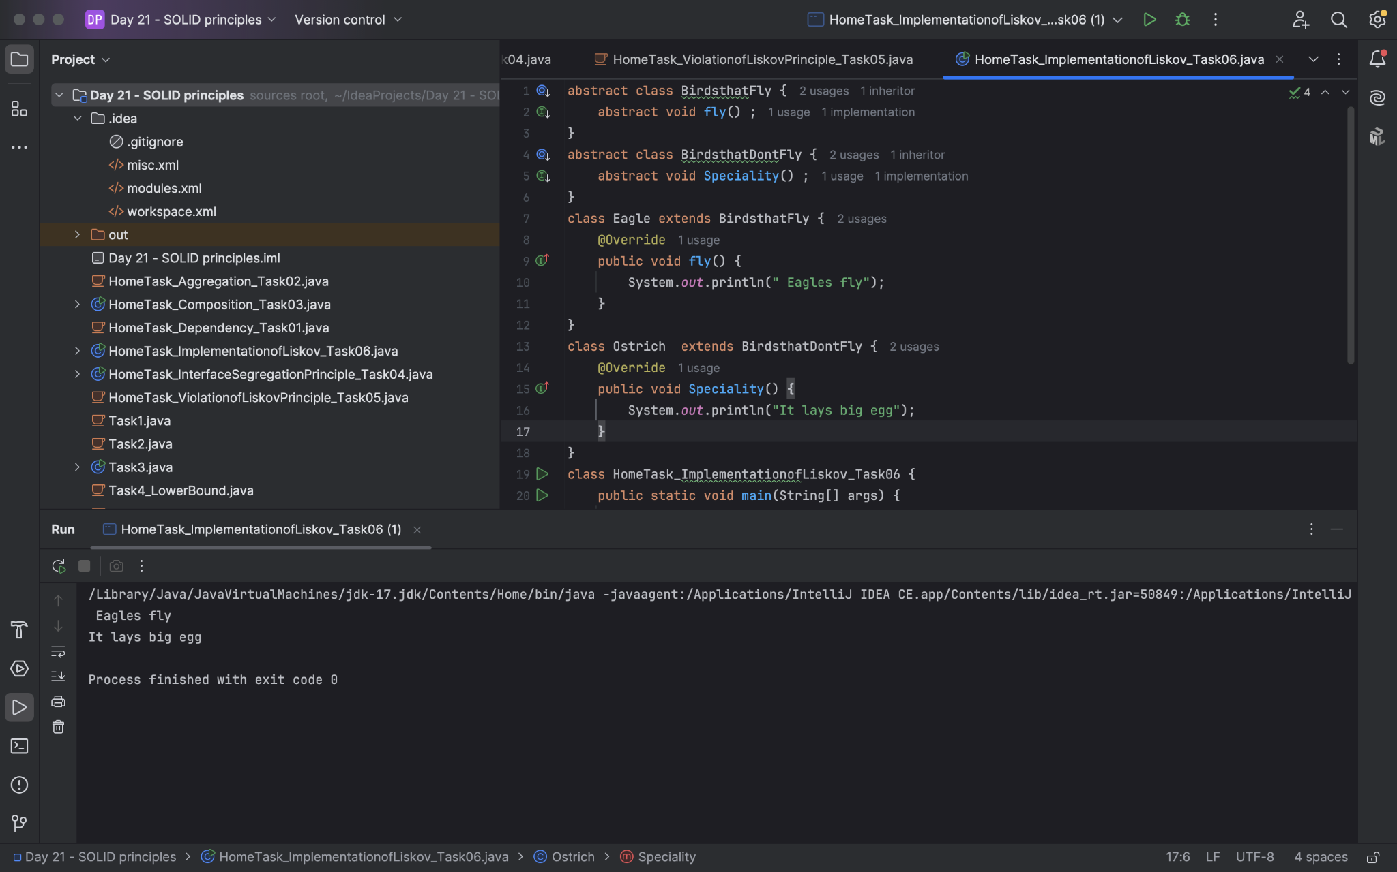
Task 07:

Violation of Interface Segregation principle

interface ICalcShapesArea {
calcArea();
calcVolume();
}
class Circle implements ICalcShapesArea {
calcArea() { sout()};
calcVolume() { sout()}; // dummy implentation as it been forced
}
class Sphere implements ICalcShapesArea {
calcArea() { sout()};
calcVolume() { sout()};
}
class Driverclass {
psvm( ,... ) {
}
}

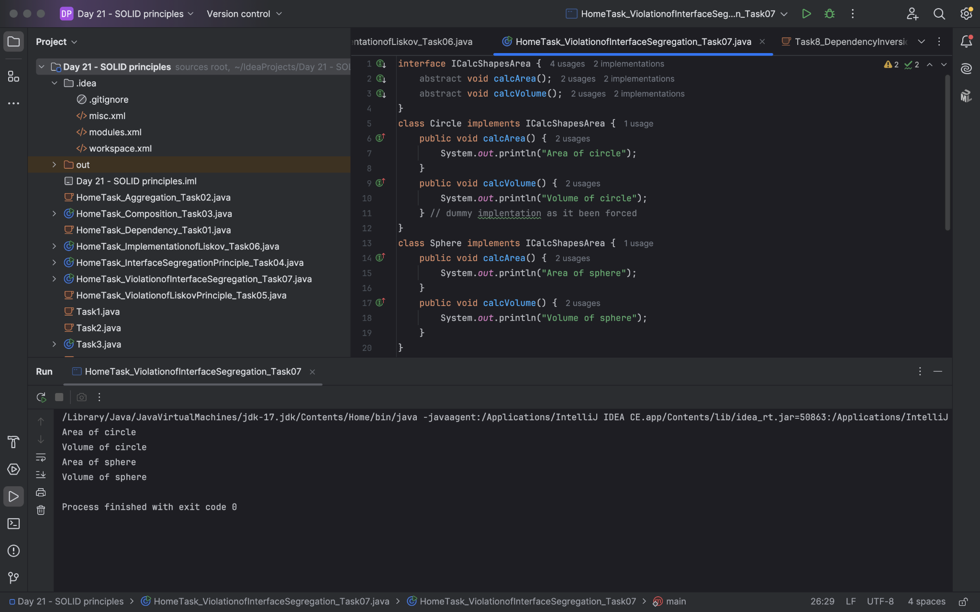

Task 08:

Implementation of Interface Segregation Principle

interface ICalcArea {
calcArea(); calcPerimeter();
}
interface ICalcVolume {
calcVolume();
}
class Circle implements ICalcArea {
@Override
calcArea() { sout()};
}
class Sphere implements ICalcArea, ICalcVolume {
@Override
calcArea() { sout()};
calcVolume() { sout()};
}
class Driverclass {
psvm( ,... ) {
}
}

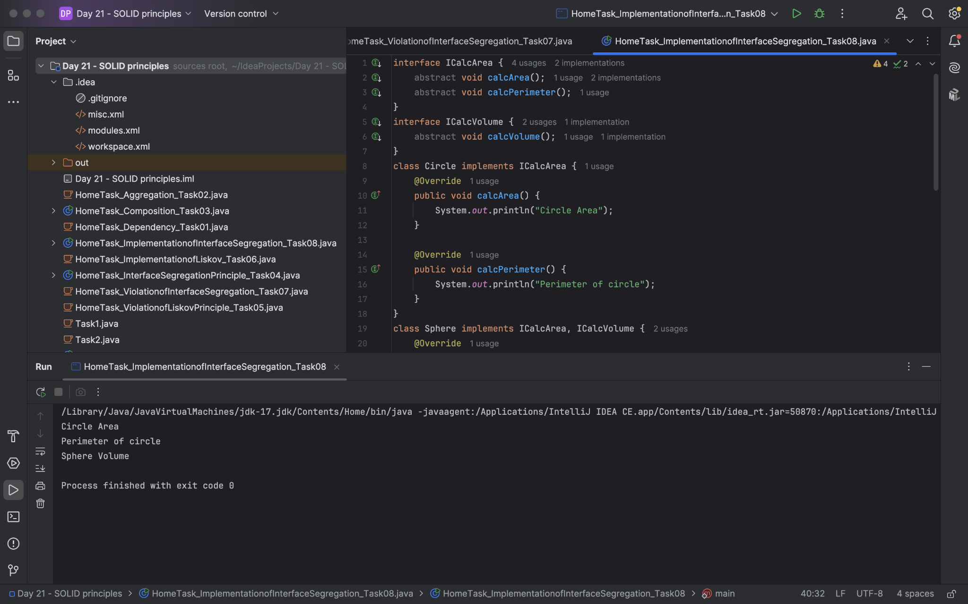

Task 09:

Dip violation code:

DIP - Dependency inversion Principle - Violation:

public class Clothes {
void seeRating() {

}
void viewSample() {

}
}
public class Cupboard { // high level class
// completly depending on low level class
//called clothes, books, vessels etc..
Clothes cobj;
void addClothes(Clothes cobj) {

}
void CustomizeClothes() {

}
}

customer asks to add books in the code:

public class Books {
void seeRating() {

}
void readSample() {

}
}

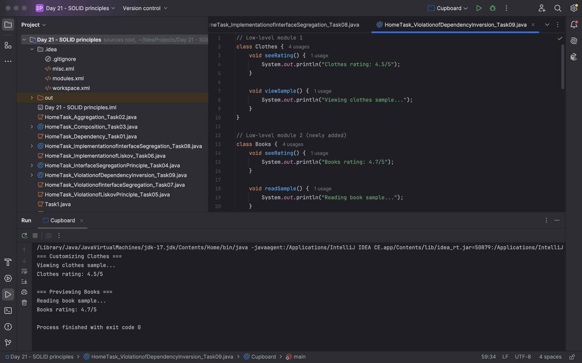

Task 10:

Now DIP implementation:

Implementing Dependency Inversion Principle
public interface IProduct {
void SeeReviews();
void getSample();
}
public class Clothes implements IProduct {
@Override
public void SeeReviews() {

}
@Override
public void getSample() {

}
}
public class Books implements IProduct {
@Override
public void SeeReviews() {

}
@Override
public void getSample() {

}
}

